Please see below for alternate instructions to my previous email re how you can see which players are registered to your team so far. You may need to do this ideally using a laptop/pc/ ipad rather than on a mobile phone..

To see players registered to my team :
Step 1 : log in to DRIBL (via pc/laptop - not mobile phone)
https://app.dribl.com/

Step 2 : click on the arrow dropdown for the FSC Summer team

Step 3 : click on members / manage members
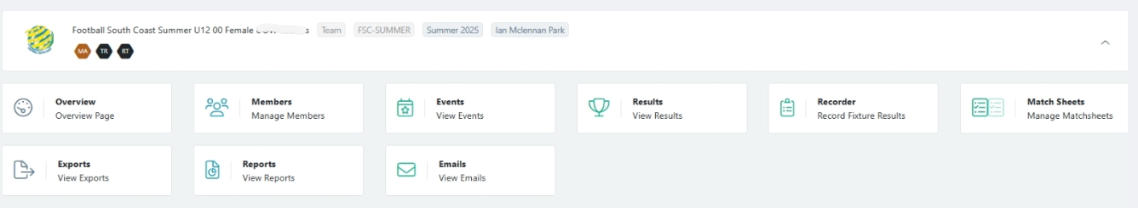

You should now be able to see a list of your team players who have registered.

Please let me know via reply email to summerfootball@footballsouthcoast.com if anyone has advised you that they have registered but are not showing on your list.

