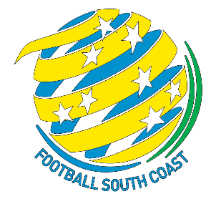


Play Down Age Group – Application
Reference: FSC-053
For: Junior Players
Issued Date: 26 February 2026
Version: 1.0

Overview of the Application
Applications MUST be completed and submitted to FNSW by the Association.
Applications received directly from clubs, parents or others will be redirected to the relevant Association for resubmission.
Only applications supported by both the player’s Club and Association will be considered.
Before completing this form, the Club and Association must refer to the FNSW Play Down Guidelines.
The only time consideration will be given to a player to play below their own age group is where there is a medical certificate or specialist report confirming that a player has a diagnosed medical or developmental condition, or disability and as a result, it is more suitable for the player to play down.
All applications are subject to annual submission and approval by FNSW.

Step 1 – Club to complete the information below and save as a word document.

Club

Player’s Name | First
Player’s Name | Surname
Player’s FFA number
Gender
Natural Age Group |  |  | Requested Age Group
Player’s Current Weight (kg) |  |  | Player’s Current Height (cm)
Diagnosed Medical or Developmental Condition/s

Step 2

The Club emails this document to FSC and attaches the following three documents which is mandatory:

- Letter or email from Parent / Guardian requesting play down approval

- Letter or email of support from the Club
- Medical certificates, reports or statements from GP or specialist confirming diagnosis.
The Club may also attach any other supporting documentation or reports.

Step 3
Football South Coast will review.

Step 4
After review, Football South Coast will either submit an application to Football NSW or provide a response to the Club.

Step 5 – (Submission to FNSW)
Football NSW will consider application and provide a determination to FSC who in turn will provide the response to the Club.

